Developing camera calibration software for MOONS FPU testing

Issue: 0.4

Date: 29th April 2019

Author: Alexander Lay

# Change Record

|  |  |  |  |
| --- | --- | --- | --- |
| Issue | Date | Sections Affected | Change Description |
| 0.1 | 3rd April 2019 | All | Initial version |
| 0.2 | 5th April 2019 | All | Add extra sections, references and clarifications. |
| 0.3 | 8th April 2019 | Introduction, Assumptions made, Further analysis | Expand on python language and package version dependencies. Add extra details on the movement range of the MOONS FPUs. Add further analysis of the best configuration |
| 0.4 | 29th April 2019 | Keystone correction, Assumptions, Determining the best configuration | Grammar corrections. Correct inaccurate statements in assumptions. Add high accuracy config generation flowchart. |

Contents

Change Record 1

Introduction 3

Learning the undistortion process 4

Lens distortion 4

Keystone correction 6

Real world coordinates 8

The camera_calibration package 9

Creation 9

Testing 9

Assumptions made 9

Points lie on the plane of the calibration grid 9

Calibration grids are rectilinear 10

The camera won’t change 10

OpenCV can detect the grid 10

Dependency availability 10

Repository structure 10

Determining the best configuration 12

Further analysis 13

Appendix A: Calibration Configuration Accuracies 15

Appendix B: Highest accuracy configuration values 17

Appendix C: Distcor dot grid compatible blob detector setup 18

# Introduction

A method is needed to convert an (x, y) point in an image to (x, y) coordinates on a plane. For us, this is to determine the position of MOONS Fibre Positioning Units (FPUs) for gearbox calibration[1]. However, the camera’s lens and positioning introduce distortions into the image that prevent a direct conversion using a scaling factor of the number of pixels per millimetre. As this problem is not unique to MOONS, the distortion correction software is to be independent so that can be used in other projects too.

The MOONS calibration project specification requires that the position of the FPUs is accurate to a within 20 microns, although ideally we will be able to achieve an order of magnitude better. The calibration software is being built to run in Python 2.7, so this software must be able to run in that environment too, but should also run in Python 3 to be usable in future projects.

# Learning the undistortion process

## Lens distortion

The initial problem with the images from the calibration rigs camera is that of lens distortion. This can be seen in the raw image below as the straight lines of the dot grid bulge outwards from the center.

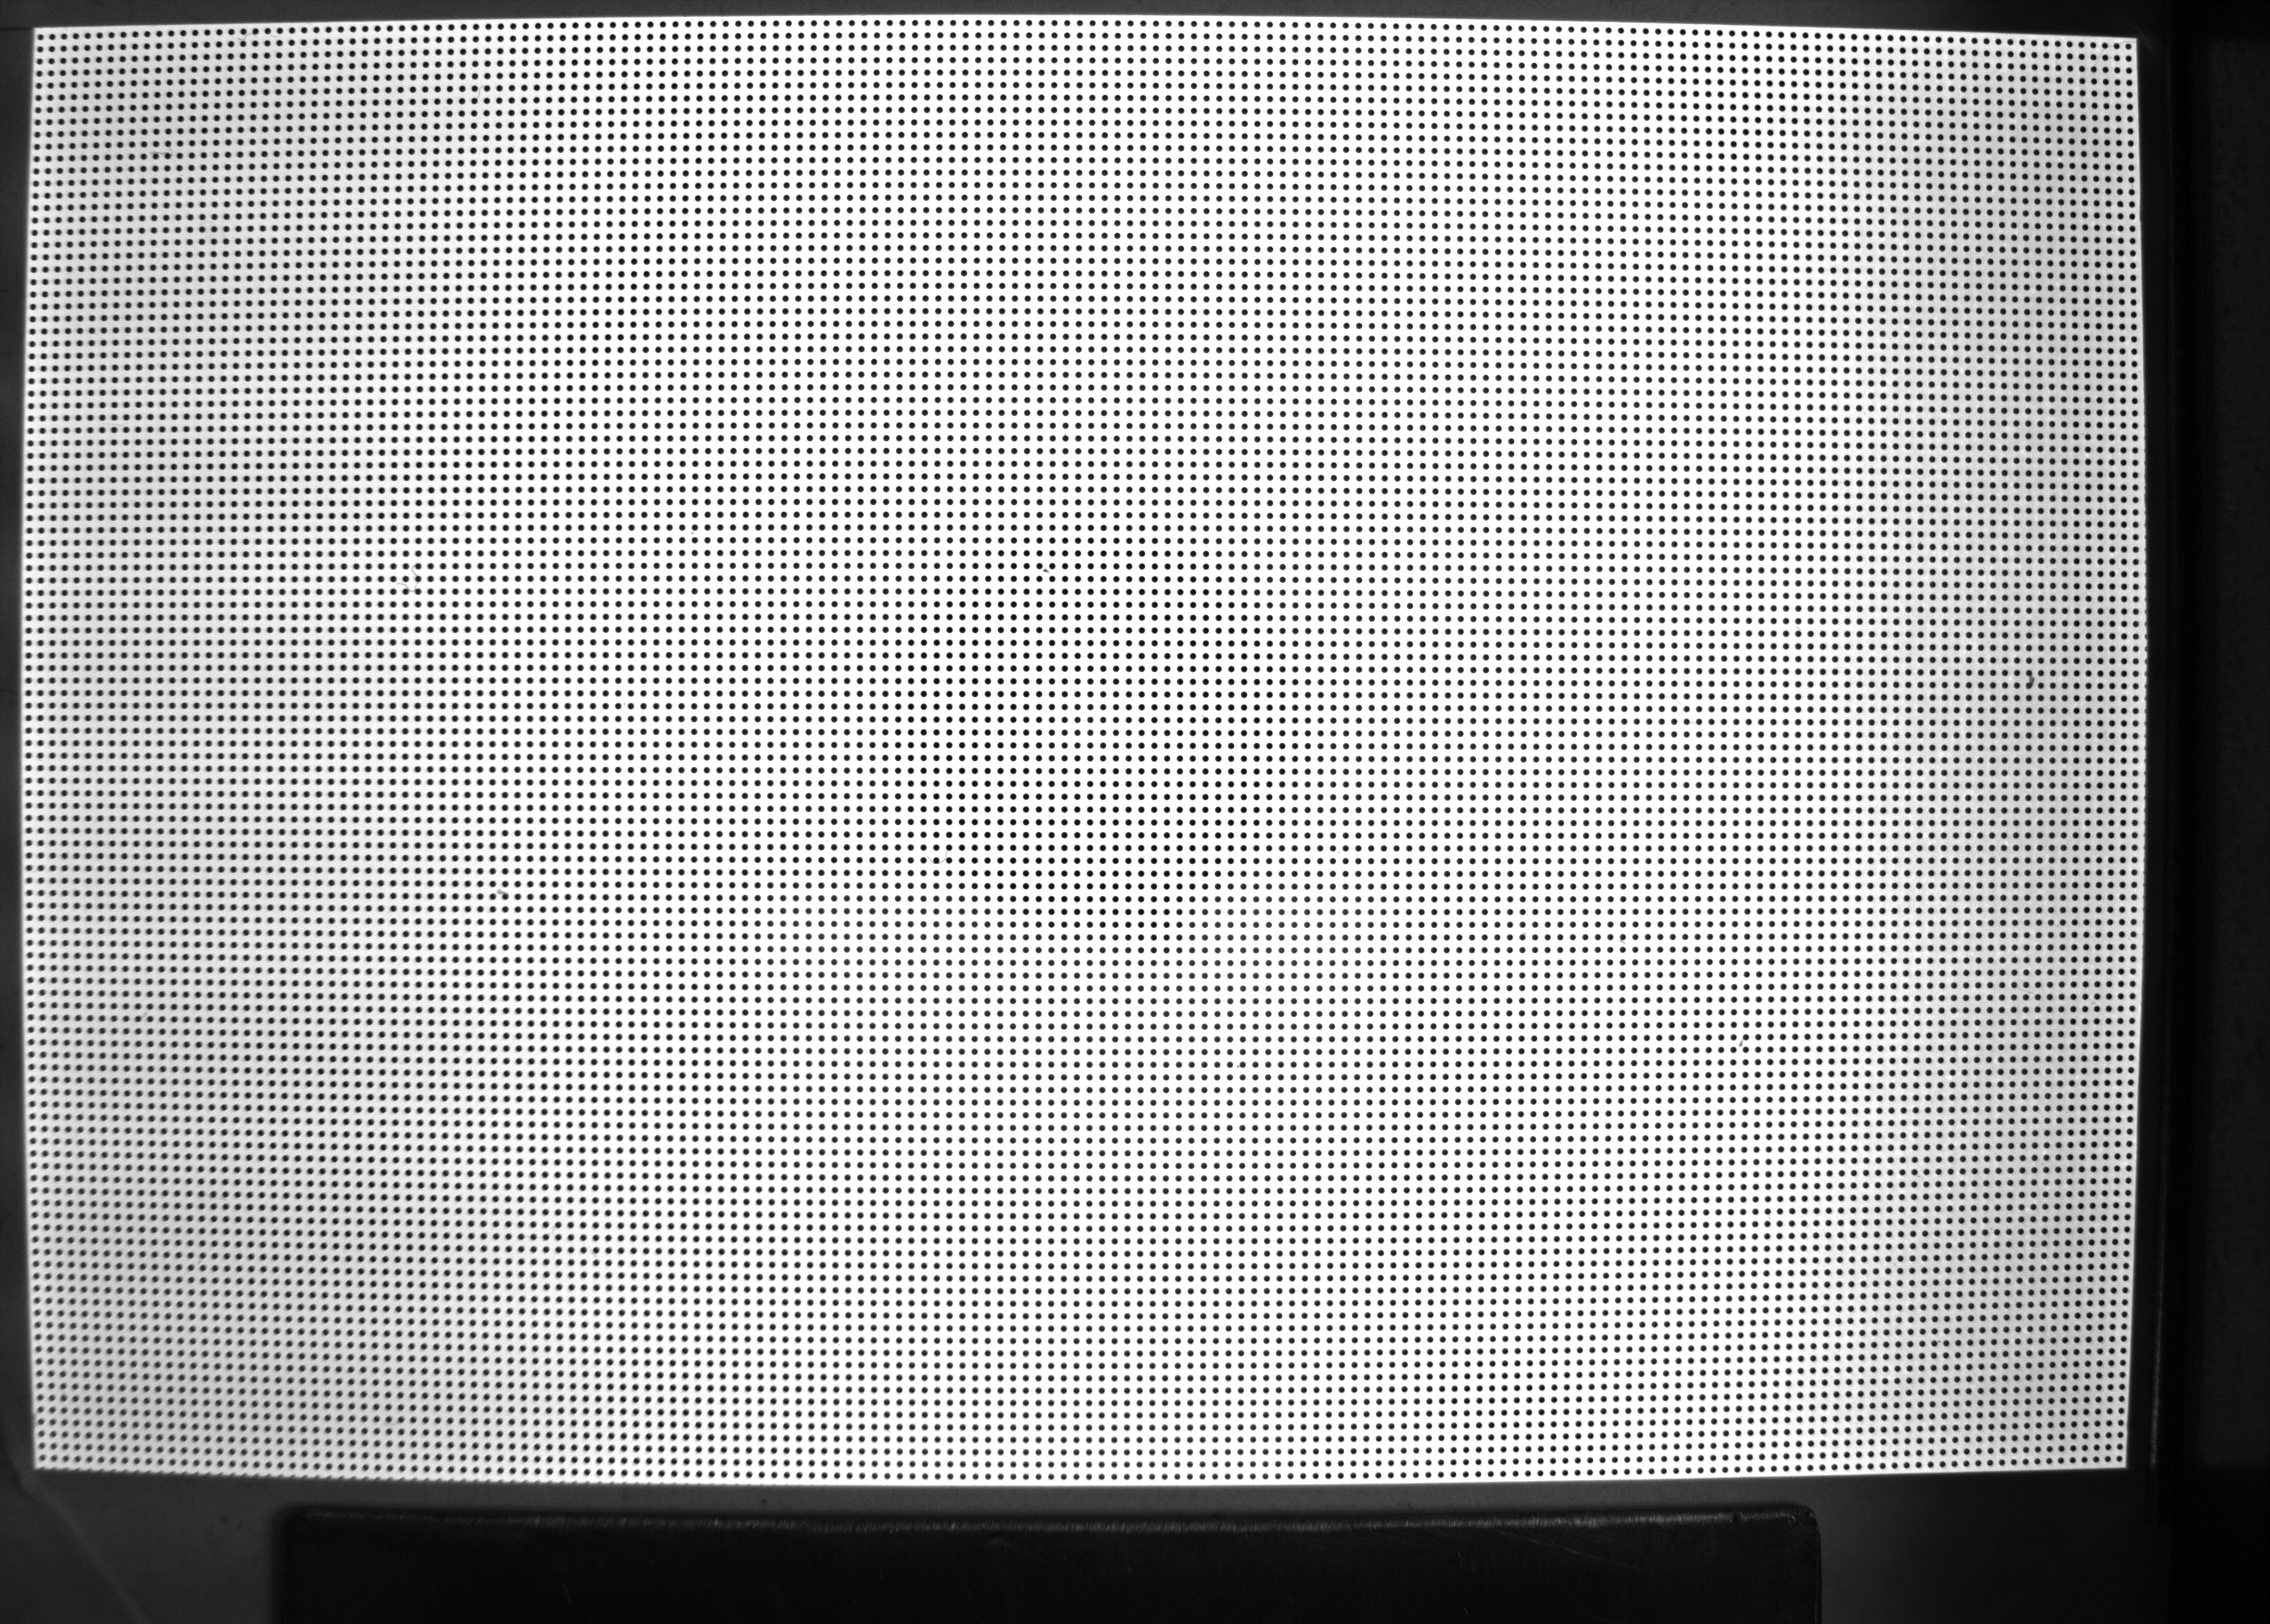

Figure 1: dot grid plate calibration image distcor_01

OpenCV is an open source computer vision library that contains a large number of established and tested image manipulation and processing functions[2]. It also has Python bindings available on PyPI that allows it to be easily used in our environment[3]. Of relevance here are the functions ‘calibrateCamera’ and ‘getOptimalNewCameraMatrix’. These provide camera matrices and distortion coefficients that can be used in the ‘undistort’ function to fix the lens distortion.

As an argument, ‘calibrateCamera’ requires a grid of points in the image, so first we must detect this grid. Two functions exist in OpenCV for this purpose, one for detecting grids of dots, like the one in distcor_01, and one for grids of corner intersection points in a chessboard pattern.

The simplest of these is the ‘findChessboardCorners’ which takes the image and the numbers of rows and columns in the grid. ‘findCirclesGrid’ also takes the image and grid size, but also flags describing the type of grid search to perform, a blob detector, and a configuration object. This need for the blob detector presents certain difficulties:

* For it to run at a useable speed, it must have filter parameters set to reduce the search space from all possible dots to just the type we are looking for. These parameters must be set up manually.
* The blob detector should be capable of detecting every dot in the grid, excluding any false positives.

After a few tries of fiddling with the blob detectors parameters, a good setup was found that would detect most of the 19,720 dots in the image[4]. By saving a copy of the image with the selected dots highlighted, the issue became clear. To the right of the image, two dots are joined together, and just above the center is an extra blob that was also being selected. Presumably these are both due to specs of dirt or dust on the grid plate when the image was being taken.

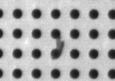

Figure 2: Joined blobs in discor_01

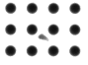

Figure 3: Extra dirt blob in distcor_01

To rectify this, I edited these errors out of the images by hand, removing the extra dot, and separating the conjoined dots to leave as round looking remnants as I could.

While these changes meant the blob detector was able to locate every dot in the image, OpenCV’s grid detection algorithm was still not able to detect the grid, presumably due to some combination of the high number of dots, their density, and the severity of the lens distortion, as a point near the center of an edge may lie directly between the ends of the next row out.

To work around this, I considered editing a sparser grid of dots, but decided against that due to the amount of precise drawing it would have taken to ensure certain rows and columns were left untouched. Instead, I decided to manufacture a chessboard image based on the dot grid, using the Inkscape vector graphics editor to draw quadrilaterals with corners that lined up with the approximated center of every tenth dot.

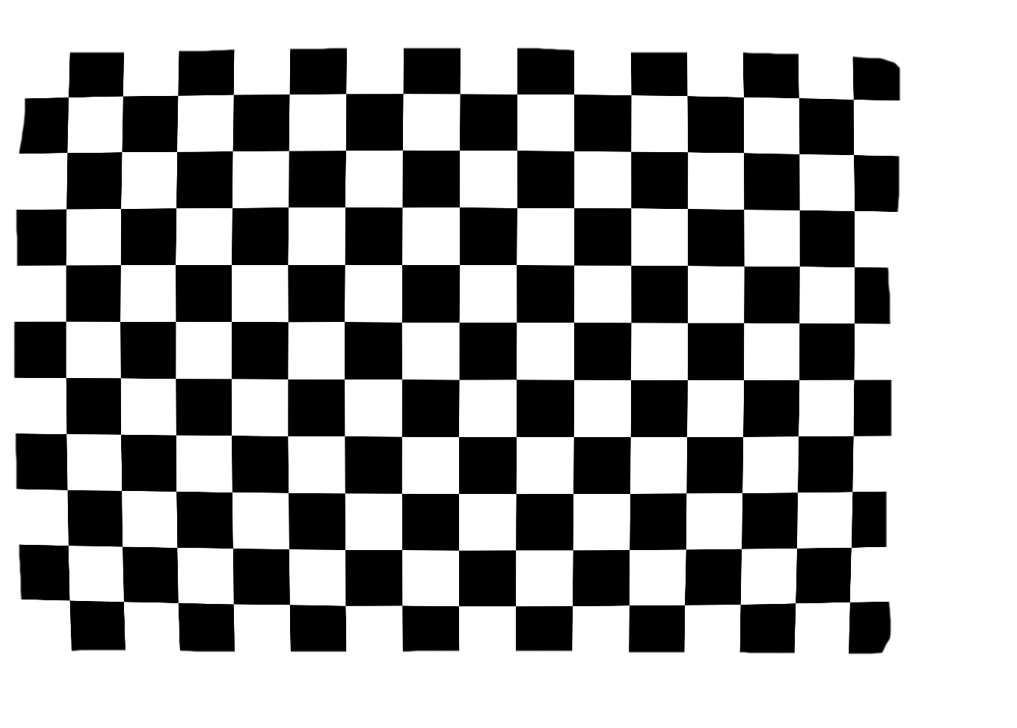

Figure 4: Mocked chessboard image based on distcor_01

Using this image in the ‘findChessboardCorners’ method was a success, allowing the lens distortion parameters to be calculated. As a test of the blob detector, the blob detector and ‘findCirclesGrid’ method were able to locate the grid in the original dots image if it was undistorted with the lens correction parameters.

## Keystone correction

The correction for lens distortion fixes images so that straight lines in the real world appear again as straight lines. However, if the camera is off axis, then one side of the calibration image will be closer to the camera than the other side, and rather than being a rectangle in the undistorted image, it will appear as a parallelogram.

This can be corrected with a homography transformation, which can also correct for any rotation of the grid, ensuring that the corrected grid is both rectangular and aligned with the x/y axes of the image.

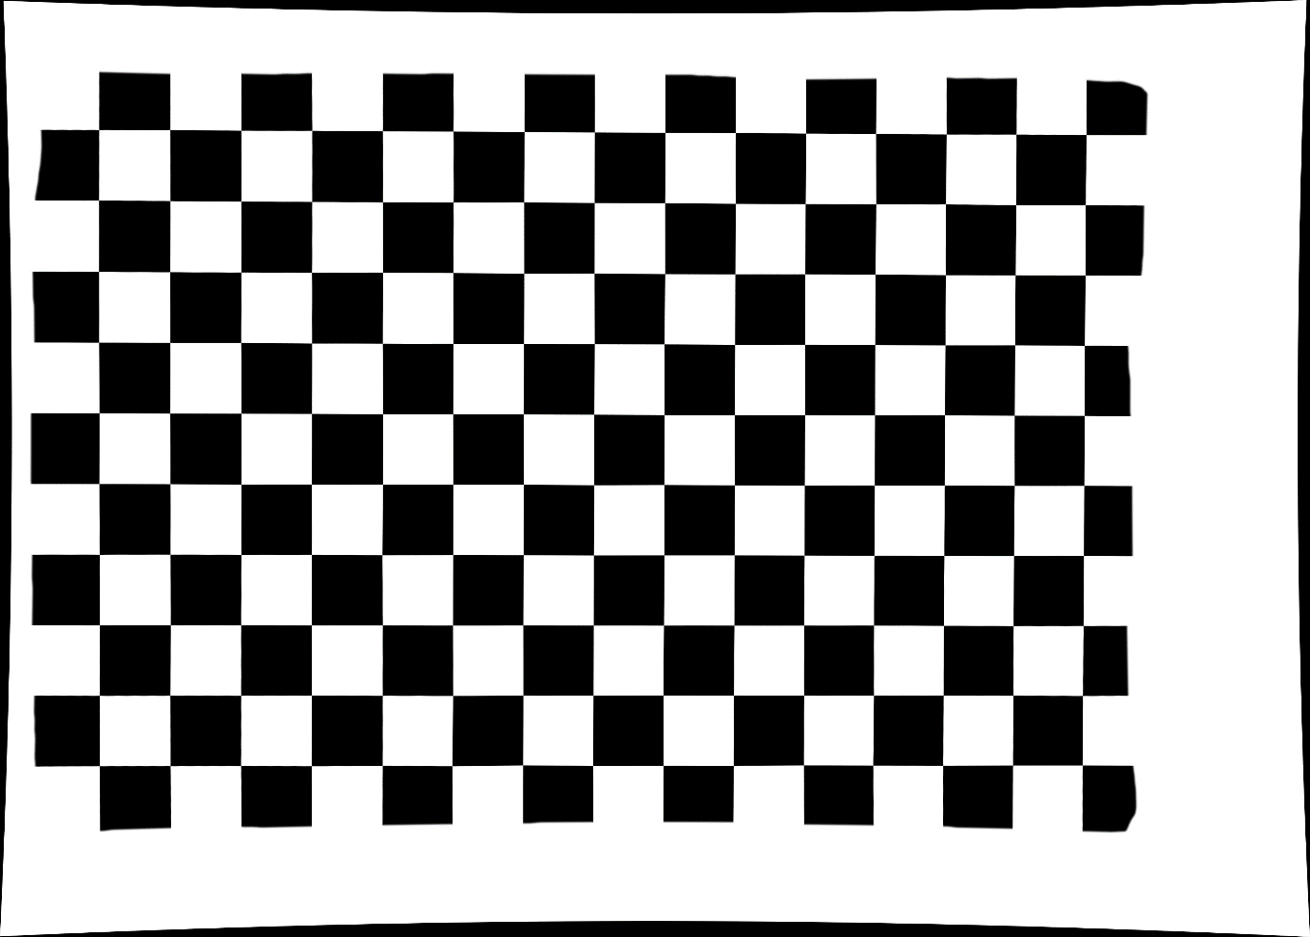

Figure 5: The mocked Chessboard image with lens correction

OpenCV’s ‘findHomography’ method requires a set of points in the image being provided to it, and their corresponding locations in the homography corrected image. The points in the image can simply be the corners of the grid. To prevent any loss of scale or information, I added code to determine which side of the parallellogram has the most pixels per column or row, and use that to calculate the size of the rectangle in the corrected image, with an arbitrarily chosen 50 pixel border.

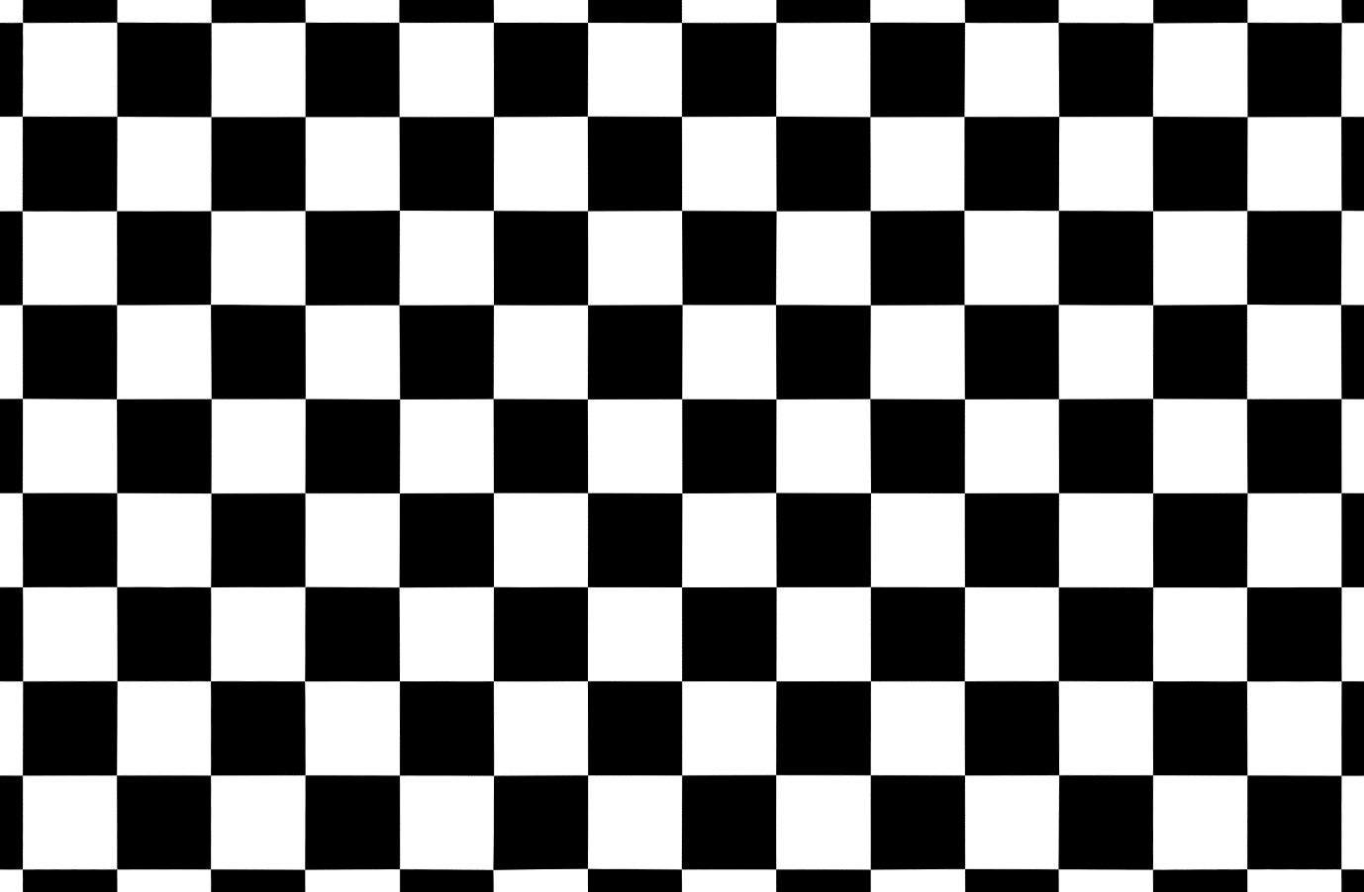

Figure 6: Mocked chessboard with lens and homography corrections applied

## Real world coordinates

Having corrections to transform the image to a regular grid, it then becomes simple to determine a set of real world coordinates for a point in the image. If a pixel’s x coordinate is a third of the way between the left and right sides of the grid, then its position must be a third of the distance between the sides.

# The camera_calibration package

With the ability to perform the required processing steps, the next task was to wrap this up into a usable product. I decided on a python package, which would allow it to be easily installed using the python package manager, pip.

## Creation

The entire correction and conversion process uses a large number of parameters:

* Camera matrix
* Distortion coefficients
* Ideal camera matrix
* Homography matrix
* The four grid corners in the undistorted image
* The four grid corners in real world coordinates

These were wrapped up into two classes, Corners and Config, which would be populated by a call to Config.generate() providing a chessboard image to setup lens correction, and a dot image for homography correction. The classes were provided in a package along with two methods, correct_point and correct_points, which would take one or many points from the distorted image along with a Config object, and convert them to coordinates in the calibration grid. These classes and functions were then wrapped up into a package that could be installed via pip.

To make the package usable in a wider variety of setups, the generate() method was replaced with a set of methods that could be used to populate the lens distortion and homography parameters separately, and using either a dots image, chessboard image, or an array of the grids coordinates. A correct_image method was also added, along with an enum for indicating to the correction methods which of the correction steps should be performed.

The code can be found at <https://github.com/ukatc/camera-calibration> along with installation instructions, usage examples, and the calibration images used and referenced throughout this document.

## Testing

To accompany the package is a set of unit tests to verify its functionality.

These have been run on my development machine for all supported versions of python (2.7, 3.4, 3.5, 3.6, 3.7). In addition, I have verified it by generating configs from, and correcting, chessboard images on both an Ubuntu 18.04 VM and on the desktop in the MOONS verification lab where this software will be used in production.

## Assumptions made

### Points lie on the plane of the calibration grid

The conversion from points in a lens and keystone corrected image returns coordinates on the plane of the keystone correction grid, so some scaling would be needed if imaged points to be positioned are not on the plane.

We know that as the MOONS FPU’s move, their endpoints actually move along the surface of a 4 meter radius sphere, within a circular zone up to 5cm in diameter. As a result, each positioner would deviate from the flat surface vertically by about 0.5mm, making a difference of about 5 microns to the apparent location of the positioner on the flat plane. However, this deviation can be externally characterised and rectified, so this software will still meet the needs of MOONS.

### Calibration grids are rectilinear

OpenCV performs its lens distortion calculations assuming the grids provided are meant to be made of straight lines, and corrects them to this state. If the imaged grids are curved or distorted through other means the calibration will be inaccurate.

### The camera won’t change

If the lens of the camera is swapped, or it’s moved/rotated relative to the plane used as a reference for real world measurements, then any corrections made on new images with a calibration from images taken before those changes happened will be invalid.

This also means that images from one camera shouldn’t be corrected with a configuration made with images from another.

### OpenCV can detect the grid

When an image is passed to the Config’s “populate*()” methods, the config can only be built if OpenCV’s chessboard or dot grid detection methods are able to find their grid in the image. If it can’t complete, then the methods will return False, which must be taken into account when using the software.

## Repository structure

* camera_calibration/
  + The calibration package
  + __init__.py
    - Exposes the required classes and functions from configuration and correction modules for use from the top level of the package.
  + __version__.py
    - Stores the packages version numbers
  + configuration.py
    - Contains the Config and Corner classes
  + correction.py
    - Contains the methods for performing corrections, and the Correction level enum class.
* example_scripts/
  + Python scripts that demonstrate how to use the calibration package.
  + calibrate_chessboard.py
    - Builds a configuration from a chessboard image and saves corrected copies of it’s calibration image
  + store_precise_calibration.py
    - Builds the high precision calibration configuration detailed in the next section and saves it to file.
  + analyse_precise_calibration.py
    - Loads the config generated by the previous script and generates accuracy information about it, including a histogram and heatmap of the deviation for each point in the dot grid.
* sample_images/
  + Images of the calibration grids referenced in the repository’s tests and sample scripts. Descriptions of each are given in the directory’s README.
* tests/
  + A python package containging test functions for the camera_calibration package. These are run with the ‘pytest’ command from the repository’s root directory.

# Determining the best configuration

To determine the accuracy of a configuration we need a set of points in distorted image space and their expected calibration plane coordinates. The initial configuration I tested used the mocked chessboard to calibrate lens distortion, and the distcor_01 dot grid to calibrate the homography.

The points being tested were the grid corners, points at the approximate middles of each grid edge, and the center. To determine these accurately, I ran a dot detector on distcor_01 and filtered the points by their approximate coordinates determined by hovering the mouse over them in an image editor. As the dot grid has 0.5mm spacing between rows and columns, it was a simple process to determine their positions on the grid in real world units. Across those 9 reference points, the average deviation from expectation was 8 microns, with a maximum deviation for a single point of 25 microns[5].

While quite accurate, the range for acceptable maximum deviation was set at 20 microns, and ideally significantly less than that. It also seemed inelegant to be using the mocked chessboard image to produce our calibrations, due to the required time it would take to produce such an image.

So I tried Config’s made with various other combinations of images, including a new set of chessboard calibration images that were taken, with various image adjustments. For these, I used the points from the chessboard grid image as inputs and calculated the expectations based on the grid size. Unfortunately, none of these combinations had accuracy as good as the mocked chessboard and distcor_01 combo[6].

Following a discussion with Steven, we came up with another approach. If we undo the lens distortion on discor_01 using the lens distortion from a chessboard image, we can then detect the grid in the dots image. We can also detect the points in the undistorted distcor_01, and apply the lens correction on them. Then, for each point in the original image, we can find the location in the grid data structure that it should occupy by finding the location that most closely matches its distortion corrected value. We could then try to determine a more accurate distortion correction using the grid in the original image. This has potential for improvement as the dot grids we are using are etched onto glass plates with micron accuracy, while the chessboard images are made with a regular inkjet printer. Even if they were done at high resolution 600DPI, we’d be using a dot spacing 42 microns, giving a higher variability to the location of the grids points compared to the glass plates.

Config generation

Chess image

Dots image

Approx. config

Lens corrected dot image

Lens correction

OpenCV grid detection

Approx. lens corrected dot grid data structure

Grid mapping

Dot detection

Dot locations

Lens correction

Lens corrected dot locations

Fully distorted dot grid data structure

Config generation

High accuracy config

Figure 7: Flowchart of the proposed process for producing higher accuracy configurations

While the process of searching 19,720 times through 19,720 points is quite a slow one, taking 6 minutes to run on my laptop[7], it works, producing the grid data structure for the original distorted dot grid image. Unfortunately, once OpenCV’s calibrateCamera function was called with this grid it would consume all available memory and still not have completed after 20 minutes. However, by creating a sparse copy of the grid that only contained every other row and column, it could complete this call in less than a minute consuming only 2GB of RAM.

Using this sparse grid derived lens distortion, an average deviation of 7 microns, with maximum of 19 microns was achieved. By switching the homography to be determined with all points in the dot grid instead of just the corners, this would be improved to a 3 micron average and 18 micron maximum. It should be noted though that despite its improvements in this situation, not all configurations are improved by using all points for the homography, so it was made into an argument for the homography property population methods.

To determine the best images and homograph setting to use, I wrote a script to try calibrations using all available dot grid images, in both full grid and corner only homography modes. The best configuration produced used image distcor_04, with an average deviation of 1.1 microns, and maximum deviation of 10.2 microns[8].

## Further analysis

With this high accuracy configuration produced, I developed a script to further investigate its accuracy. For instance, if there is a pattern or spread to the inaccuracies that could potentially lead to further improvement.

As we already know it to be accurate to within a tolerance of 11 microns for all points, I wrote a script that would locate and correct the points in the distcor_04 image, and compare them to the nearest point on a 0.5mm grid, calculating a histogram and heatmap of the deviations[9].

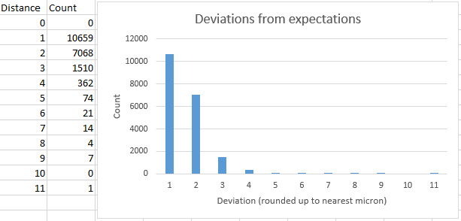

Figure 8: Histogram of deviations for grid points in Distcor_04 corrected with the high accuracy calibration configuration

As would be expected from the low average, the majority of points have low deviations, with more than half being accurate to less than a micron, and very few having high values.

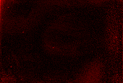

Figure 9: Heatmap of deviation in corrected location across the Distcor_04 grid. Brighter red means higher deviation.

The heatmap image is also encouraging, as there doesn’t appear to be a strong gradient or grouping of high brightness pixels in the image that might suggest an error in the correction. Of interest are the small hotspots with the brightest pixels. Near the center of the right side of the image, two vertically adjacent pixels are both much brighter than their surroundings. Taking their pixel coordinates and looking at the original grid, they line up with the conjoined blobs shown in Figure 2 that were manually edited apart. Other dirt can also be found when referencing hot pixel locations with the original image



Figure 10: The dot corresponding to the near center hot pixel



Figure 11: The central dot is the hot pixel a short diagonal distance from the top left corner



Figure 12: The dots for a group of hot pixels near the center of the top left quadrant

Given that many of the extreme deviations appear to line up with physical artifacts in the image, and the near uniformity of the rest of the heatmap, it seems that most of the extreme deviations (which it should be noted are still incredibly small at < 11 microns) are due to errors in point detection due to dust, and not in the calibration/correction steps. It is easily conceivable that producing a new image of the dot grid under cleaner conditions could generate a configuration with reduced maximum deviation when analysing its source image. However, as the points with low deviation vastly outnumber those with high deviation, I believe the larger errors are not greatly influencing OpenCV’s internal optimiser functions, and that while the maximum deviation may drop, I suspect any improvement in the average deviation would be minimal.

# Appendix A: Calibration Configuration Accuracies

|  |  |  |  |  |  |
| --- | --- | --- | --- | --- | --- |
| Lens correction image | Keystone correction image | Homography points used | Points assessed | Average deviation (mm) | Maximum deviation (mm) |
| Mocked chessboard | Distcor_01 dot grid | Corners only | Corners, edge middles & center | 0.007744171885450431 | 0.024592731619686663 |
|  | | | | | |
| Brightness/contrast enhanced 002 chessboard | Distcor_01 dot grid | Corners only | Corners, edge middles & center | 0.014642425080844464 | 0.03434263582352467 |
| Brightness/contrast enhanced 002 chessboard | | Corners only | Full 8x6 chess grid | 0.03930753162714686 | 0.10803360641805183 |
| Mocked chessboard | | Corners only | Full 15x10 chess grid | 0.013251843213749092 | 0.032943701291307234 |
| Otsu thresholded 002 chessboard | | Corners only | Full 8x6 chess grid | 0.033487211566522394 | 0.1295513021319049 |
|  | | | | | |
| Brightness/contrast enhanced 002 chessboard | Distcor_01 dot grid | Full grid | Corners, edge middles & center | 0.01480831903284257 | 0.06258862664693551 |
| Brightness/contrast enhanced 002 chessboard | | Full grid | Full 8x6 chess grid | 0.029803304046409337 | 0.06034524091309046 |
| Mocked chessboard | | Full grid | Full 15x10 chess grid | 0.012010950182420236 | 0.035468910144781 |
| Otsu thresholded 002 chessboard | | Full grid | Full 8x6 chess grid | 0.02650891977079113 | 0.09703288680574501 |
|  | | | | | |
| Distcor_01 dot grid | | Corners only | Full 170x116 dot grid | 0.0068365532033461155 | 0.018673387313718398 |
| Distcor_01 dot grid | | Full grid | Full 170x116 dot grid | 0.0022701536138096307 | 0.017721708969434244 |
| Distcor_02 dot grid | | Corners only | Full 170x116 dot grid | 0.004218925580149891 | 0.012243381261439354 |
| Distcor_02 dot grid | | Full grid | Full 170x116 dot grid | 0.0017728766168080838 | 0.01416300054462748 |
| Distcor_03 dot grid | | Corners only | Full 170x116 dot grid | 0.004020683715625367 | 0.013397027196077464 |
| Distcor_03 dot grid | | Full grid | Full 170x116 dot grid | 0.001639502352099444 | 0.016362264638251155 |
| Distcor_04 dot grid | | Corners only | Full 170x116 dot grid | 0.00287922279757079 | 0.011354858920247096 |
| Distcor_04 dot grid | | Full grid | Full 170x116 dot grid | 0.0010981354562486117 | 0.01018928316974898 |
| Distcor_05 dot grid | | Corners only | Full 170x116 dot grid | 0.00317002779156954 | 0.010845371042456366 |
| Distcor_05 dot grid | | Full grid | Full 170x116 dot grid | 0.001215071633446034 | 0.01147723711604149 |
| Distcor_06 dot grid | | Corners only | Full 170x116 dot grid | 0.005261551785365835 | 0.015087019176068832 |
| Distcor_06 dot grid | | Full grid | Full 170x116 dot grid | 0.0020601171450275956 | 0.016513938577371812 |
| Distcor_07 dot grid | | Corners only | Full 170x116 dot grid | 0.004083109193400039 | 0.01278590298858148 |
| Distcor_07 dot grid | | Full grid | Full 170x116 dot grid | 0.0018219986170447994 | 0.01690539348426784 |
| Distcor_08 dot grid | | Corners only | Full 170x116 dot grid | 0.00269622930308711 | 0.011706794411879575 |
| Distcor_08 dot grid | | Full grid | Full 170x116 dot grid | 0.0010995301500154018 | 0.011350326425007346 |
| Distcor_09 dot grid | | Corners only | Full 170x116 dot grid | 0.0024908190244764318 | 0.011224473643648016 |
| Distcor_09 dot grid | | Full grid | Full 170x116 dot grid | 0.0011715860677561096 | 0.010530386642667236 |
| Distcor_10 dot grid | | Corners only | Full 170x116 dot grid | 0.003967508597548494 | 0.014405578262619428 |
| Distcor_10 dot grid | | Full grid | Full 170x116 dot grid | 0.0016008545701445454 | 0.01743122229457938 |
| Distcor_11 dot grid | | Corners only | Full 170x116 dot grid | 0.0025916096989949374 | 0.010309196599181789 |
| Distcor_11 dot grid | | Full grid | Full 170x116 dot grid | 0.0013611496063765836 | 0.010269859369846665 |

Deviation being defined as the hypotenuse of a right angled triangle, where the differences in x and y axis values for the calculated and expected points are the remaining sides

# Appendix B: Highest accuracy configuration values

The following code will create a new configuration object that with the computed parameters from the discor_01 full grid homography configuration. It requires imports of the Config and Corners classes from the camera_calibration package, as well as numpy’s array and float32.

Config(

distorted_camera_matrix=array(

[

[5.4757654619649838e03, 0.0000000000000000e00, 1.8977786697421388e03],

[0.0000000000000000e00, 5.4740252291335883e03, 1.2989798726569404e03],

[0.0000000000000000e00, 0.0000000000000000e00, 1.0000000000000000e00],

]

),

distortion_coefficients=array(

[

[

-0.2703967509743592,

0.26348057588236573,

-0.00114882690035892,

0.0008420969428869703,

-0.3254696368352247,

]

]

),

undistorted_camera_matrix=array(

[

[5.2042651367187500e03, 0.0000000000000000e00, 1.8987904794491624e03],

[0.0000000000000000e00, 5.2145927734375000e03, 1.2942836798625649e03],

[0.0000000000000000e00, 0.0000000000000000e00, 1.0000000000000000e00],

]

),

homography_matrix=array(

[

[1.0039925372428886e00, -1.3890548470602269e-03, -2.1259054931649462e02],

[-6.2817760571344554e-03, 1.0047590476566779e00, -1.0791976944207451e02],

[-3.2798224330415689e-06, -2.3172919100429813e-06, 1.0000000000000000e00],

]

),

grid_image_corners=Corners(

top_left=array([50.0, 50.0], dtype=float32),

top_right=array([3599.0, 50.0], dtype=float32),

bottom_left=array([50.0, 2465.0], dtype=float32),

bottom_right=array([3599.0, 2465.0], dtype=float32),

),

grid_space_corners=Corners(

top_left=array([0.0, 0.0], dtype=float32),

top_right=array([84.5, 0.0], dtype=float32),

bottom_left=array([0.0, 57.5], dtype=float32),

bottom_right=array([84.5, 57.5], dtype=float32),

),

)

# Appendix C: Distcor dot grid compatible blob detector setup

With the image corrections to remove dirt on the grid, the following blob detector parameters can locate all dots in a distcor dot grid image:

params = cv.SimpleBlobDetector_Params()  
params.minArea = 50  
params.maxArea = 1000  
params.filterByArea = **True**params.minCircularity = 0.2  
params.filterByCircularity = **True**params.blobColor = 0  
params.filterByColor = **True**dot_detector = cv.SimpleBlobDetector_create(params)

1. See the document VLT-TRE-MON-14620-1018 – FPU Verification Requirements
2. <https://opencv.org/>
3. <https://pypi.org/project/opencv-python/>
4. Appendix C: Distcor dot grid compatible blob detector setup
5. Deviation being defined as the hypotenuse of a right angled triangle, where the differences in x and y axis values for the calculated and expected points are the remaining sides.
6. Full listings of configurations and accuracies are in Appendix A: Calibration Configuration Accuracies
7. Running Windows 10 with 16GB RAM and an i7-6700HQ @ 3.1GHz
8. The values for this config are listed in Appendix B: Highest accuracy configuration values.

   Additionally, a script to generate this config exists on the repo at <https://github.com/ukatc/camera-calibration/blob/develop/example_scripts/store_precise_calibration.py>
9. This script can be found in the repo under example_scripts/analyse_precise_calibration.py